## Updated MR inheritance + competition + MR scale (removed initial rescale, converted all to 0-1) – Recruitment 0.003

|  |  |  |
| --- | --- | --- |
|  | | |
| age_impact = 1.0  MR_death_impact = F  MR_lateintro = F  recruitment_const = 0.003  comp_impact = 0.9 |  |  |
| age_impact = 1.0  MR_death_impact = 0.05  MR_lateintro = F  recruitment_const = 0.003  comp_impact = 0.9 |  |  |
|  |  |  |
| age_impact = 1.0  MR_death_impact = 0.1  MR_lateintro = F  recruitment_const = 0.003  comp_impact = 0.9 |  |  |
| age_impact = 1.0  MR_death_impact = 0.1  MR_lateintro = T - 2000  recruitment_const = 0.003  comp_impact = 0.9 |  |  |
| age_impact = 1.0  MR_death_impact = 0.15  MR_lateintro = F  recruitment_const = 0.003  comp_impact = 0.9 |  |  |
| age_impact = 1.0  MR_death_impact = 0.2  MR_lateintro = F  recruitment_const = 0.003  comp_impact = 0.9 |  |  |
| age_impact = 1.0  MR_death_impact = 0.2  MR_lateintro = T - 2000  recruitment_const = 0.003  comp_impact = 0.9 |  |  |
| age_impact = 1.0  MR_death_impact = 0.5  MR_lateintro = F  recruitment_const = 0.003  comp_impact = 0.9 |  |  |
| age_impact = 1.0  MR_death_impact = 0.5  MR_lateintro = T - 2000  recruitment_const = 0.003  comp_impact = 0.9 |  |  |

|  |  |  |
| --- | --- | --- |
| Pop 1  Age imp val = 1.0  MR imp val = 0.5  Pop 2  Age imp val = 1.0  MR imp val = 0.05 | Blue = runs without maladaptation events (running it solo)  Red = runs with maladaptation events (running both pops in conjunction)  Where for each side pop 1, maladapts with pop 2 (triangle events)  For the left side, pop 1, the maladapted pop is brought higher with the influence of pop2  For the right side, the population is |  |

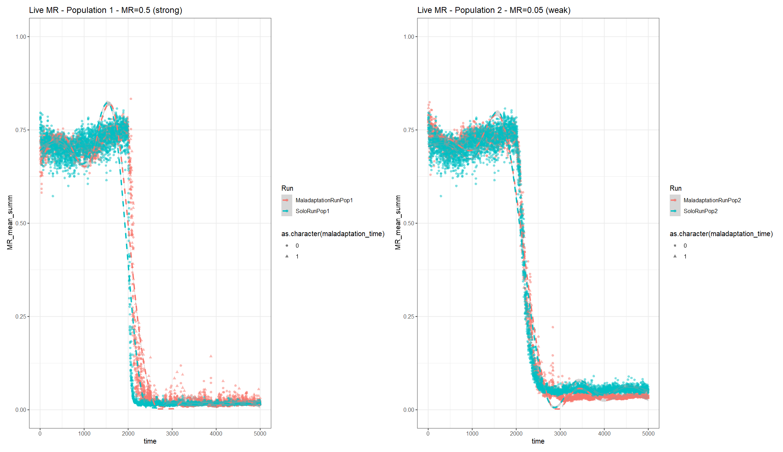

## Change MR recruitment to ^2 instead of ^4; adjust MR inheritance by -0.08

|  |  |  |
| --- | --- | --- |
| age_impact = 1.0  MR_death_impact = F  MR_lateintro = F  recruitment_const = 0.003  comp_impact = 0.9 |  |  |
| age_impact = 1.0  MR_death_impact = 0.1  MR_lateintro = T - 1000  recruitment_const = 0.003  comp_impact = 0.9 |  |  |
| age_impact = 1.0  MR_death_impact = 0.2  MR_lateintro = T - 1000  recruitment_const = 0.003  comp_impact = 0.9 |  |  |
|  |  |
| T=2000 |  |  |
|  |  |
| age_impact = 1.0  MR_death_impact = 0.5  MR_lateintro = F  recruitment_const = 0.003  comp_impact = 0.9 |  |  |
| age_impact = 1.0  MR_death_impact = 0.5  MR_lateintro = T - 1000  recruitment_const = 0.003  comp_impact = 0.9 |  |  |
| age_impact = 1.0  MR_death_impact = 0.75  MR_lateintro = T - 1000  recruitment_const = 0.003  comp_impact = 0.9 |  |  |
| age_impact = 1.0  MR_death_impact = 0.8  MR_lateintro = T - 2000  recruitment_const = 0.003  comp_impact = 0.9 |  |  |
| age_impact = 1.0  MR_death_impact = 1.0  MR_lateintro = T - 1000  recruitment_const = 0.003  comp_impact = 0.9 |  |  |
|  |  |
| Pop 1  Age imp val = 1.0  MR imp val = 0.2  Pop 2  Age imp val = 1.0  MR imp val = 0.8 | Was run without maladaptation at the start to confirm initial pops overlapped  Q: Why does it drop at the start? |  |

## Change MR recruitment to ^2 instead of ^4

|  |  |  |
| --- | --- | --- |
| Pop 1  age_impact = 1.0  MR_death_impact = 0.5  MR_lateintro = T - 2000  recruitment_const = 0.003  comp_impact = 0.9 |  |  |
| Pop 2  age_impact = 1.0  MR_death_impact = 0.05  MR_lateintro = T - 2000  recruitment_const = 0.003  comp_impact = 0.9 |  |  |
| Pop 1  Age imp val = 1.0  MR imp val = 0.5  Pop 2  Age imp val = 1.0  MR imp val = 0.05 | Blue = runs without maladaptation events (running it solo)  Red = runs with maladaptation events (running both pops in conjunction)  Where for each side, red, pop 1, maladapts with pop 2 (triangle events):   * For the left side, pop 1, the maladapted pop is **pulled up** with the influence of pop2 (less resistant) * For the right side, pop 2 is **pulled** **down** with the influence of pop1 (more resistant) |  |

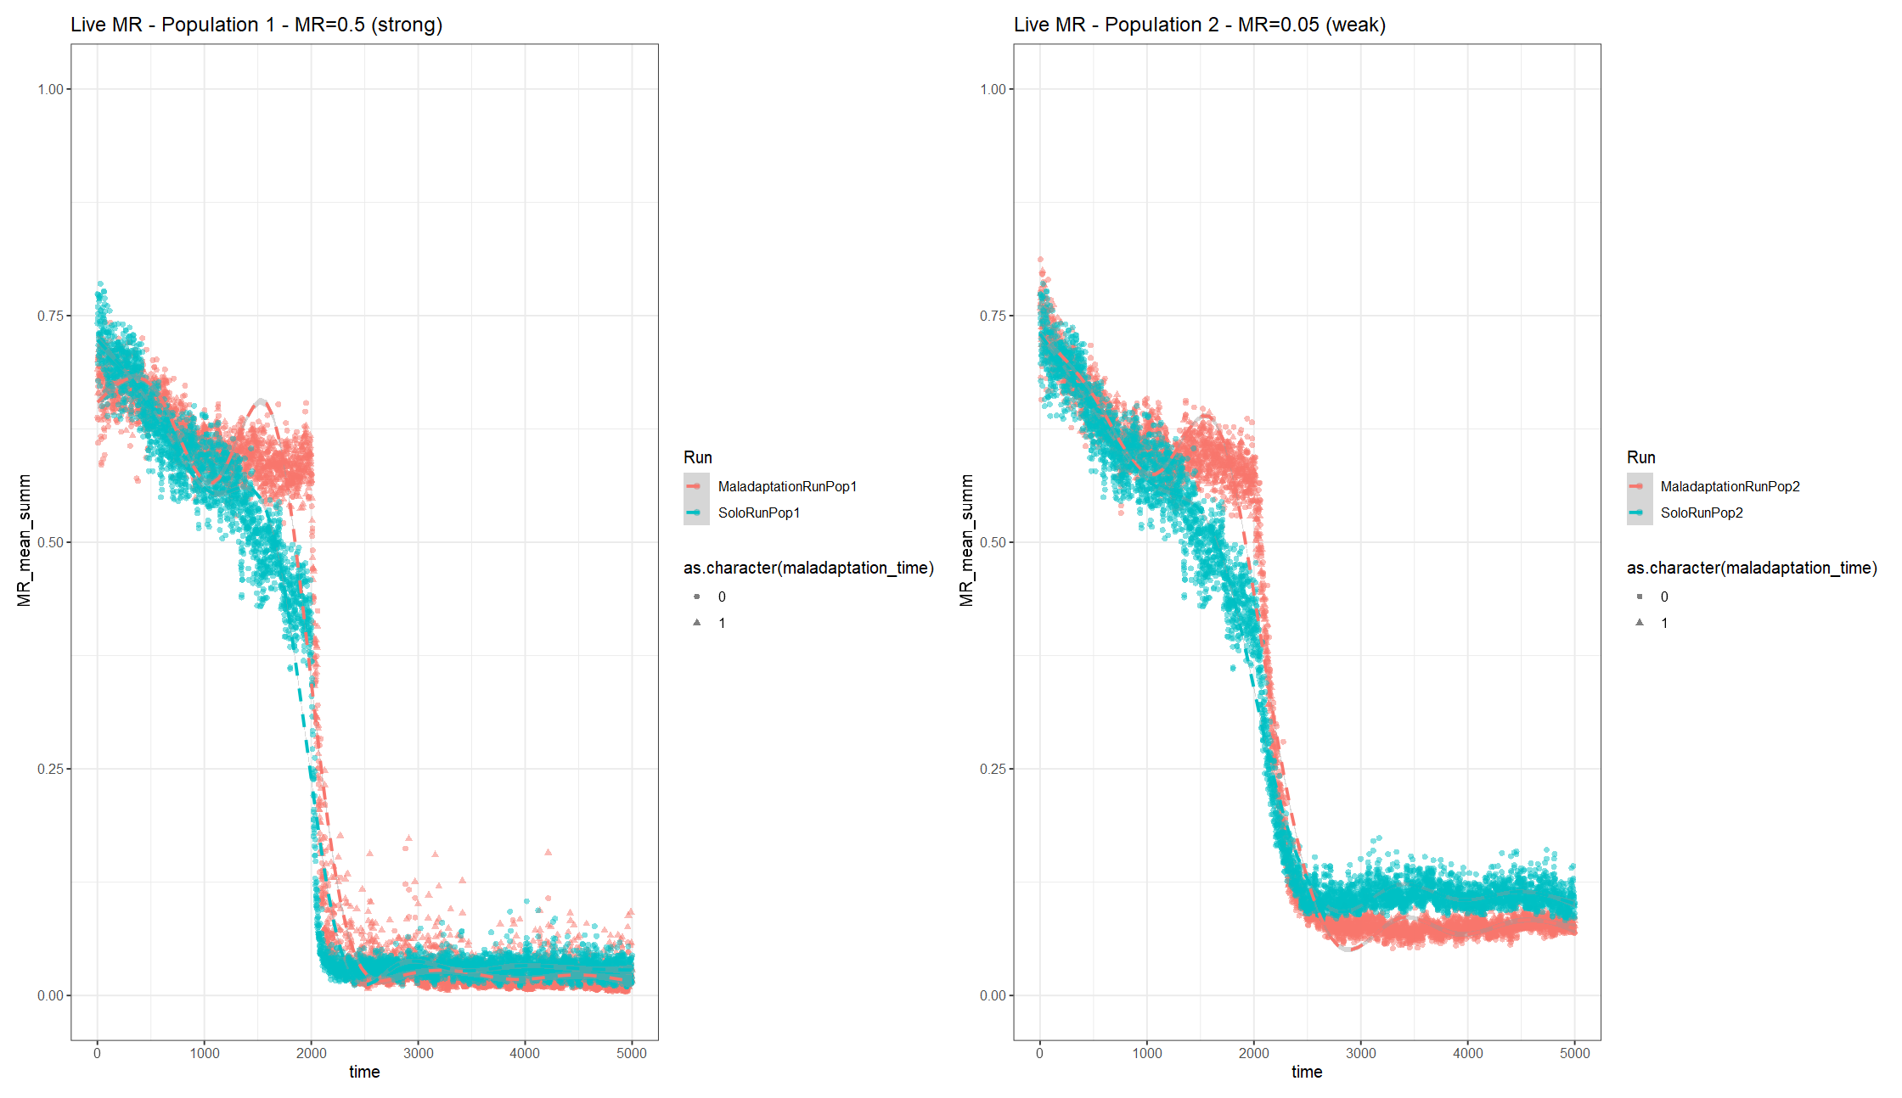

|  |  |  |  |  |  |
| --- | --- | --- | --- | --- | --- |
| Impact _ MR | 0.10 | 0.12 | 0.14 | 0.16 | 0.18 |
|  |  |  |  |  |  |
|  |  |  |  |  |  |
|  |  |  |  |  |  |

**Adjusted recruitment to account for MR and age**

|  |  |
| --- | --- |
|  |  |

### Intervention

Data_sim_3

Altered mortality – age of interception indivs *4 until mortality_age_shift/4 (~35)

#### Base:

* Recruitment adjustment = 0 & ^2
* MR=0.12
* MR introduced at 1000

#### Intervention_100-0.15-0.1_T1025:

* Population size = 1000
* Init pop MR mean= 0.787; MR sd=0. 385
* Recruitment adjustment = 0 & ^2
* MR=0.12
* MR introduced at 1000
* intercept_timepoint = 1025
* Dropped mean MR from 0.4468093 -> 0.4385565
* intercept_indiv = 100
* intercept_MR_mean = 0.15
* intercept_MR_sd = 0.1

# A tibble: 2 × 2

Run min_pop_size

*<chr>* *<dbl>*

1 Base 1362.

2 Resistance Intervention 1598.

#### Intervention_300-0.15-0.1_T1025:

* Population size = 1000
* Init pop MR mean= 0.787; MR sd=0. 385
* Recruitment adjustment = 0 & ^2
* MR=0.12
* MR introduced at 1000
* intercept_timepoint = 1025
  + Dropped mean MR from 0.4468093 -> 0.4235052
* intercept_indiv = 300
* intercept_MR_mean = 0.15
* intercept_MR_sd = 0.1

# A tibble: 2 × 2

Run min_pop_size

*<chr>* *<dbl>*

1 Base 1362.

2 Resistance Intervention 1222.

#### Intervention_300-0.10-0.05_T1025:

* Population size = 1000
* Init pop MR mean= 0.787; MR sd=0. 385
* Recruitment adjustment = 0 & ^2
* MR=0.12
* MR introduced at 1000
* intercept_timepoint = 1025
  + Dropped mean MR from 0.499 -> 0.4718
* intercept_indiv = 300
* intercept_MR_mean = 0.10
* intercept_MR_sd = 0.05

# A tibble: 2 × 2

Run min_pop_size

*<chr>* *<dbl>*

1 Base 1362.

2 Resistance Intervention 1470.

#### Intervention_300-0.15-0.10_T1050:

* Population size = 1000
* Init pop MR mean= 0.787; MR sd=0. 385
* Recruitment adjustment = 0 & ^2
* MR=0.12
* MR introduced at 1000
* intercept_timepoint = 1050
  + Dropped mean MR from 0.4458399 -> 0.4202595
* intercept_indiv = 300
* intercept_MR_mean = 0.15
* intercept_MR_sd = 0.10

> live_size_wind_mean %>%

+ group_by(Run) %>%

+ summarise(min_pop_size = min(mean_wind_size))

# A tibble: 2 × 2

Run min_pop_size

*<chr>* *<dbl>*

1 Base 1362.

2 Resistance Intervention 1367.

#### Intervention_300-0.15-0.10_T1025:

* Population size = 1000
* Init pop MR mean= 0.787; MR sd=0. 385
* Recruitment adjustment = 0 & ^2
* MR=0.12
* MR introduced at 1000
* intercept_timepoint = 1025
  + Dropped mean MR from 0.4468093 -> 0.4235052
* intercept_indiv = 300
* intercept_MR_mean = 0.15
* intercept_MR_sd = 0.1

# A tibble: 2 × 2

Run min_pop_size

*<chr>* *<dbl>*

1 Base 1362.

2 Resistance Intervention 1192.

#### Intervention_500-0.15-0.10_T1025:

* Population size = 1000
* Init pop MR mean= 0.787; MR sd=0. 385
* Recruitment adjustment = 0 & ^2
* MR=0.12
* MR introduced at 1000
* intercept_timepoint = 1025
  + Dropped mean MR from 0.4468093 -> 0.4102694
* intercept_indiv = 500
  + After addition (*N =* 4035)
* intercept_MR_mean = 0.15
* intercept_MR_sd = 0.1

# A tibble: 2 × 2

Run min_pop_size

*<chr>* *<dbl>*

1 Base 1362.

2 Resistance Intervention 1635.

#### Intervention_1000-0.15-0.1_T1025:

* Population size = 1000
* Init pop MR mean= 0.787; MR sd=0. 385
* Recruitment adjustment = 0 & ^2
* MR=0.12
* MR introduced at 1000
* intercept_timepoint = 1025
  + Dropped mean MR from 0.4468093 -> 0.3825454
* intercept_indiv = 1000
  + After addition (*N =* 4535)
* intercept_MR_mean = 0.15
* intercept_MR_sd = 0.1

# A tibble: 2 × 2

Run min_pop_size

*<chr>* *<dbl>*

1 Base 1362.

2 Resistance Intervention 1845.

#### Intervention_300-0.15-0.1_T1025_PopSize4000:

* Population size = 4000
* Init pop MR mean= 0.787; MR sd=0. 385
* Recruitment adjustment = 0 & ^2
* MR=0.12
* MR introduced at 1000
* intercept_timepoint = 1025
  + Dropped mean MR from 0.4468093 -> 0.3825454
* intercept_indiv = 300
* intercept_MR_mean = 0.15
* intercept_MR_sd = 0.1

# A tibble: 2 × 2

Run min_pop_size

*<chr>* *<dbl>*

1 Base 6280.

2 Resistance Intervention 7039.

**Reducing recruitment: to 0.0025 from 0.003**

#### Intervention_300-0.15-0.1_T1025 _ResistInitMR:

* Population size = 1000
* Init pop MR mean= 0.25; MR sd=0. 1
* Recruitment adjustment = 0 & ^2
* MR=0.12
* MR introduced at 1000
* intercept_timepoint = 1025
  + Dropped mean MR from 0.243588 -> 0.2376324
* intercept_indiv = 300
* intercept_MR_mean = 0.15
* intercept_MR_sd = 0.1

> live_size_wind_mean %>%

+ group_by(Run) %>%

+ summarise(min_pop_size = min(mean_wind_size))

# A tibble: 2 × 2

Run min_pop_size

*<chr>* *<dbl>*

1 Base 2011.

2 Resistance Intervention 2485.

E.g., 0.3 recruit

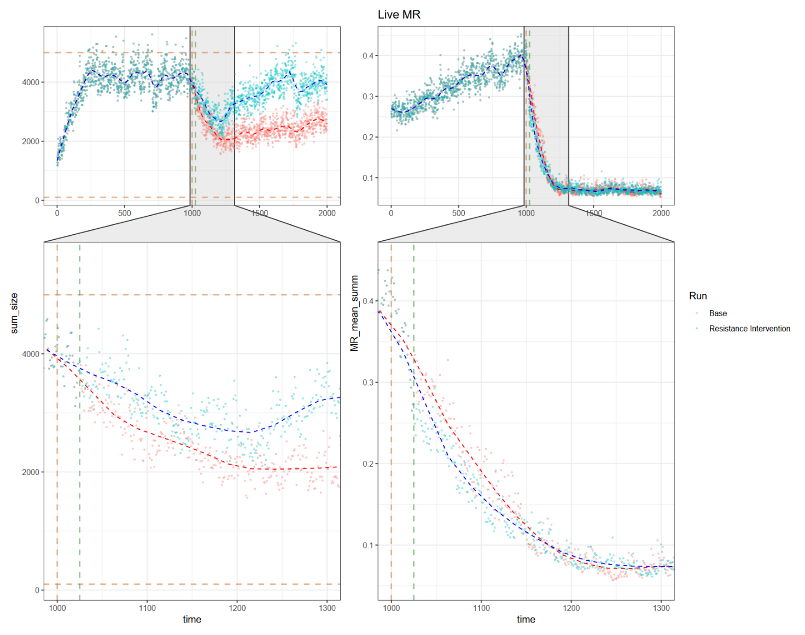

#### Intervention_300-0.15-0.1_T1025_Rm mortality reduction_ ResistInitMR:

* Population size = 1000
* Init pop MR mean= 0.25; MR sd=0. 1
* Recruitment adjustment = 0 & ^2
* MR=0.12
* MR introduced at 1000
* intercept_timepoint = 1025
  + Dropped mean MR from 0.2764773 -> 0.2684228
* intercept_indiv = 300
* intercept_MR_mean = 0.15
* intercept_MR_sd = 0.1
* intercept_reducMort = F

# A tibble: 2 × 2

Run min_pop_size

*<chr>* *<dbl>*

1 Base 1362.

2 Resistance Intervention 1845.

#### Intervention_300-0.8-0.1_T1050:

* Population size = 1000
* Init pop MR mean= 0.787; MR sd=0. 385
* Recruitment adjustment = 0 & ^2
* MR=0.12
* MR introduced at 1000
* intercept_timepoint = 1050
  + Mean MR from 0.4468093 -> 0.4741063
* intercept_indiv = 300
* intercept_MR_mean = 0.80
* intercept_MR_sd = 0.10
* intercept_reducMort = F

> live_size_wind_mean %>%

+ group_by(Run) %>%

+ summarise(min_pop_size = min(mean_wind_size))

# A tibble: 2 × 2

Run min_pop_size

*<chr>* *<dbl>*

1 Base 1362.

2 Resistance Intervention 1330.

## Change MR recruitment to adjust for MR and age; MR recruited return back to ^4

**Base**

|  |  |  |
| --- | --- | --- |
| ## Input parameters for high MR pressure sites  ## Population parameters  population_size = 1000  population_carrying_capacity = population_size*5  population_minimum_size = population_size/10  MR_mean = 0.787 # From actual genotype data  MR_sd = 0.385  disturbance_impact_val=5 # impacts base age & MR death factor and recruitment constant  ## Mortality parameters  age_impact = 1.0 # scaled age inflicted increase - from 0 to 1, should add to 1 with MR impact val  mortality_age_shift = 150 # at what age does increases in age increase chance of death  MR_imp = T # toggle on/off for MR inflicted death increase  MR_death_impact = 0.20 # linear scaled MR inflicted death increase - from 0 to 1, should add to 1 with age impact val  MR_age_impact = 20 # scaled impact of age (ages / MR_age_impact_val) on MR inflicted death increase  MR_lateintro = T  MR_timepoint = 1000 # time point when MR is introduced  ## Recruitment parameters  recruitment_const = 0.003 # base constant for chance of recruitment  recruitment_age = 7 # age to begin recruiting  recruitment_mean = 100 # mean for PDF of normal distribution for number of recruited individuals  recruitment_sd = recruitment_mean/2 # standard deviation of number of recruited individuals  age_rec_toggle = TRUE # Takes the complimentary of the age fraction to reduce recruitment mean according to size (larger = closer to 1)  age_recruit_impact_value = 0.5 # Range from 0.01-1. Takes the exponential of this value, the higher this value, the steeper the penalisation  rec_age_shift = 100 # age shift, lower than this age recruitment for the individual is penalised  MR_rec_toggle = F # toggle on/off of MR affect on recruitment  MR_recruit_impact = 0.5 # impact of MR on recruitment, a multiplier of the individual MR to reduce recruitment chance  MR_rec_adj = 0 # Shift mean of MR status of recruited individuals  ## Intervention parameters  intercept_togg = F |  |  |
| ## Input parameters for high MR pressure sites  ## Population parameters  population_size = 1000  population_carrying_capacity = population_size*5  population_minimum_size = population_size/10  MR_mean = 0.787 # From actual genotype data  MR_sd = 0.385  disturbance_impact_val=5 # impacts base age & MR death factor and recruitment constant  ## Mortality parameters  age_impact = 1.0 # scaled age inflicted increase - from 0 to 1, should add to 1 with MR impact val  mortality_age_shift = 150 # at what age does increases in age increase chance of death  MR_imp = T # toggle on/off for MR inflicted death increase  MR_death_impact = 0.12 # linear scaled MR inflicted death increase - from 0 to 1, should add to 1 with age impact val  MR_age_impact = 20 # scaled impact of age (ages / MR_age_impact_val) on MR inflicted death increase  MR_lateintro = T  MR_timepoint = 1000 # time point when MR is introduced  ## Recruitment parameters  recruitment_const = 0.003 # base constant for chance of recruitment  recruitment_age = 7 # age to begin recruiting  recruitment_mean = 100 # mean for PDF of normal distribution for number of recruited individuals  recruitment_sd = recruitment_mean/2 # standard deviation of number of recruited individuals  age_rec_toggle = TRUE # Takes the complimentary of the age fraction to reduce recruitment mean according to size (larger = closer to 1)  age_recruit_impact_value = 0.5 # Range from 0.01-1. Takes the exponential of this value, the higher this value, the steeper the penalisation  rec_age_shift = 100 # age shift, lower than this age recruitment for the individual is penalised  MR_rec_toggle = F # toggle on/off of MR affect on recruitment  MR_recruit_impact = 0.5 # impact of MR on recruitment, a multiplier of the individual MR to reduce recruitment chance  MR_rec_adj = 0 # Shift mean of MR status of recruited individuals  ## Intervention parameters  intercept_togg = F |  |  |
| ## Input parameters for high MR pressure sites  ## Population parameters  population_size = 1000  population_carrying_capacity = population_size*5  population_minimum_size = population_size/10  MR_mean = 0.787 # From actual genotype data  MR_sd = 0.385  disturbance_impact_val=5 # impacts base age & MR death factor and recruitment constant  ## Mortality parameters  age_impact = 1.0 # scaled age inflicted increase - from 0 to 1, should add to 1 with MR impact val  mortality_age_shift = 150 # at what age does increases in age increase chance of death  MR_imp = T # toggle on/off for MR inflicted death increase  MR_death_impact = 0.12 # linear scaled MR inflicted death increase - from 0 to 1, should add to 1 with age impact val  MR_age_impact = 20 # scaled impact of age (ages / MR_age_impact_val) on MR inflicted death increase  MR_lateintro = T  MR_timepoint = 1000 # time point when MR is introduced  ## Recruitment parameters  recruitment_const = 0.003 # base constant for chance of recruitment  recruitment_age = 7 # age to begin recruiting  recruitment_mean = 100 # mean for PDF of normal distribution for number of recruited individuals  recruitment_sd = recruitment_mean/2 # standard deviation of number of recruited individuals  age_rec_toggle = TRUE # Takes the complimentary of the age fraction to reduce recruitment mean according to size (larger = closer to 1)  age_recruit_impact_value = 0.5 # Range from 0.01-1. Takes the exponential of this value, the higher this value, the steeper the penalisation  rec_age_shift = 100 # age shift, lower than this age recruitment for the individual is penalised  MR_rec_toggle = F # toggle on/off of MR affect on recruitment  MR_recruit_impact = 0.5 # impact of MR on recruitment, a multiplier of the individual MR to reduce recruitment chance  MR_rec_adj = 0 # Shift mean of MR status of recruited individuals  ## Intervention parameters  intercept_togg = F  ## Disturbance parameters (ranges from super small to big impacts)  **dist_imp = F # Turn on and off disturbance presence** |  |  |
| ## Input parameters for high MR pressure sites  ## Population parameters  population_size = 1000  population_carrying_capacity = population_size*5  population_minimum_size = population_size/10  MR_mean = 0.787 # From actual genotype data  MR_sd = 0.385  disturbance_impact_val=5 # impacts base age & MR death factor and recruitment constant  ## Mortality parameters  age_impact = 1.0 # scaled age inflicted increase - from 0 to 1, should add to 1 with MR impact val  mortality_age_shift = 150 # at what age does increases in age increase chance of death  MR_imp = T # toggle on/off for MR inflicted death increase  MR_death_impact = 0.12 # linear scaled MR inflicted death increase - from 0 to 1, should add to 1 with age impact val  MR_age_impact = 20 # scaled impact of age (ages / MR_age_impact_val) on MR inflicted death increase  MR_lateintro = T  MR_timepoint = 1000 # time point when MR is introduced  ## Recruitment parameters  recruitment_const = 0.003 # base constant for chance of recruitment  recruitment_age = 7 # age to begin recruiting  recruitment_mean = 100 # mean for PDF of normal distribution for number of recruited individuals  recruitment_sd = recruitment_mean/2 # standard deviation of number of recruited individuals  age_rec_toggle = TRUE # Takes the complimentary of the age fraction to reduce recruitment mean according to size (larger = closer to 1)  age_recruit_impact_value = 0.5 # Range from 0.01-1. Takes the exponential of this value, the higher this value, the steeper the penalisation  rec_age_shift = 100 # age shift, lower than this age recruitment for the individual is penalised  MR_rec_toggle = F # toggle on/off of MR affect on recruitment  **MR_recruit_impact = 0.75 # impact of MR on** recruitment, a multiplier of the individual MR to reduce recruitment chance  MR_rec_adj = 0 # Shift mean of MR status of recruited individuals  ## Intervention parameters  intercept_togg = F  ## Disturbance parameters (ranges from super small to big impacts)  dist_imp = F # Turn on and off disturbance presence  ^4 -> ^2 MR inheritance |  |  |
| ## Input parameters for high MR pressure sites  ## Population parameters  population_size = 1000  population_carrying_capacity = population_size*5  population_minimum_size = population_size/10  MR_mean = 0.787 # From actual genotype data  MR_sd = 0.385  disturbance_impact_val=5 # impacts base age & MR death factor and recruitment constant  ## Mortality parameters  age_impact = 1.0 # scaled age inflicted increase - from 0 to 1, should add to 1 with MR impact val  mortality_age_shift = 150 # at what age does increases in age increase chance of death  MR_imp = T # toggle on/off for MR inflicted death increase  MR_death_impact = 0.15 # linear scaled MR inflicted death increase - from 0 to 1, should add to 1 with age impact val  MR_age_impact = 20 # scaled impact of age (ages / MR_age_impact_val) on MR inflicted death increase  MR_lateintro = T  MR_timepoint = 1000 # time point when MR is introduced  ## Recruitment parameters  recruitment_const = 0.003 # base constant for chance of recruitment  recruitment_age = 7 # age to begin recruiting  recruitment_mean = 100 # mean for PDF of normal distribution for number of recruited individuals  recruitment_sd = recruitment_mean/2 # standard deviation of number of recruited individuals  age_rec_toggle = TRUE # Takes the complimentary of the age fraction to reduce recruitment mean according to size (larger = closer to 1)  age_recruit_impact_value = 0.5 # Range from 0.01-1. Takes the exponential of this value, the higher this value, the steeper the penalisation  rec_age_shift = 100 # age shift, lower than this age recruitment for the individual is penalised  MR_rec_toggle = F # toggle on/off of MR affect on recruitment  **MR_recruit_impact = 0.75 # impact of MR on** recruitment, a multiplier of the individual MR to reduce recruitment chance  MR_rec_adj = 0 # Shift mean of MR status of recruited individuals  ## Intervention parameters  intercept_togg = F  ## Disturbance parameters (ranges from super small to big impacts)  dist_imp = F # Turn on and off disturbance presence  ^4 -> ^2 MR inheritance |  |  |
| ## Input parameters for high MR pressure sites  ## Population parameters  population_size = 1000  population_carrying_capacity = population_size*5  population_minimum_size = population_size/10  MR_mean = 0.787 # From actual genotype data  MR_sd = 0.385  disturbance_impact_val=5 # impacts base age & MR death factor and recruitment constant  ## Mortality parameters  age_impact = 1.0 # scaled age inflicted increase - from 0 to 1, should add to 1 with MR impact val  mortality_age_shift = 150 # at what age does increases in age increase chance of death  MR_imp = T # toggle on/off for MR inflicted death increase  MR_death_impact = 0.20 # linear scaled MR inflicted death increase - from 0 to 1, should add to 1 with age impact val  MR_age_impact = 20 # scaled impact of age (ages / MR_age_impact_val) on MR inflicted death increase  MR_lateintro = T  MR_timepoint = 1000 # time point when MR is introduced  ## Recruitment parameters  recruitment_const = 0.003 # base constant for chance of recruitment  recruitment_age = 7 # age to begin recruiting  recruitment_mean = 100 # mean for PDF of normal distribution for number of recruited individuals  recruitment_sd = recruitment_mean/2 # standard deviation of number of recruited individuals  age_rec_toggle = TRUE # Takes the complimentary of the age fraction to reduce recruitment mean according to size (larger = closer to 1)  age_recruit_impact_value = 0.5 # Range from 0.01-1. Takes the exponential of this value, the higher this value, the steeper the penalisation  rec_age_shift = 100 # age shift, lower than this age recruitment for the individual is penalised  MR_rec_toggle = F # toggle on/off of MR affect on recruitment  **MR_recruit_impact = 0.75 # impact of MR on** recruitment, a multiplier of the individual MR to reduce recruitment chance  MR_rec_adj = 0 # Shift mean of MR status of recruited individuals  ## Intervention parameters  intercept_togg = F  ## Disturbance parameters (ranges from super small to big impacts)  dist_imp = F # Turn on and off disturbance presence  ^4 -> ^2 MR inheritance |  |  |
| ## Input parameters for high MR pressure sites  ## Population parameters  population_size = 1000  population_carrying_capacity = population_size*5  population_minimum_size = population_size/10  MR_mean = 0.787 # From actual genotype data  MR_sd = 0.385  disturbance_impact_val=5 # impacts base age & MR death factor and recruitment constant  ## Mortality parameters  age_impact = 1.0 # scaled age inflicted increase - from 0 to 1, should add to 1 with MR impact val  mortality_age_shift = 150 # at what age does increases in age increase chance of death  MR_imp = T # toggle on/off for MR inflicted death increase  MR_death_impact = 0.20 # linear scaled MR inflicted death increase - from 0 to 1, should add to 1 with age impact val  MR_age_impact = 20 # scaled impact of age (ages / MR_age_impact_val) on MR inflicted death increase  MR_lateintro = T  MR_timepoint = 1000 # time point when MR is introduced  ## Recruitment parameters  recruitment_const = 0.003 # base constant for chance of recruitment  recruitment_age = 7 # age to begin recruiting  recruitment_mean = 100 # mean for PDF of normal distribution for number of recruited individuals  recruitment_sd = recruitment_mean/2 # standard deviation of number of recruited individuals  age_rec_toggle = TRUE # Takes the complimentary of the age fraction to reduce recruitment mean according to size (larger = closer to 1)  age_recruit_impact_value = 0.5 # Range from 0.01-1. Takes the exponential of this value, the higher this value, the steeper the penalisation  rec_age_shift = 100 # age shift, lower than this age recruitment for the individual is penalised  MR_rec_toggle = F # toggle on/off of MR affect on recruitment  **MR_recruit_impact = 0.75 # impact of MR on** recruitment, a multiplier of the individual MR to reduce recruitment chance  MR_rec_adj = 0 # Shift mean of MR status of recruited individuals  ## Intervention parameters  intercept_togg = F  ## Disturbance parameters (ranges from super small to big impacts)  dist_imp = F # Turn on and off disturbance presence  ^4 -> ^2 MR inheritance |  |  |

**Intervention**

|  |  |
| --- | --- |
| ## Input parameters for high MR pressure sites  ## Population parameters  population_size = 1000  population_carrying_capacity = population_size*5  population_minimum_size = population_size/10  MR_mean = 0.787 # From actual genotype data  MR_sd = 0.385  disturbance_impact_val=5 # impacts base age & MR death factor and recruitment constant  ## Mortality parameters  age_impact = 1.0 # scaled age inflicted increase - from 0 to 1, should add to 1 with MR impact val  mortality_age_shift = 150 # at what age does increases in age increase chance of death  MR_imp = T # toggle on/off for MR inflicted death increase  MR_death_impact = 0.12 # linear scaled MR inflicted death increase - from 0 to 1, should add to 1 with age impact val  MR_age_impact = 20 # scaled impact of age (ages / MR_age_impact_val) on MR inflicted death increase  MR_lateintro = T  MR_timepoint = 1000 # time point when MR is introduced  ## Recruitment parameters  recruitment_const = 0.003 # base constant for chance of recruitment  recruitment_age = 7 # age to begin recruiting  recruitment_mean = 100 # mean for PDF of normal distribution for number of recruited individuals  recruitment_sd = recruitment_mean/2 # standard deviation of number of recruited individuals  age_rec_toggle = TRUE # Takes the complimentary of the age fraction to reduce recruitment mean according to size (larger = closer to 1)  age_recruit_impact_value = 0.5 # Range from 0.01-1. Takes the exponential of this value, the higher this value, the steeper the penalisation  rec_age_shift = 100 # age shift, lower than this age recruitment for the individual is penalised  MR_rec_toggle = F # toggle on/off of MR affect on recruitment  MR_recruit_impact = 0.5 # impact of MR on recruitment, a multiplier of the individual MR to reduce recruitment chance  MR_rec_adj = 0 # Shift mean of MR status of recruited individuals  ## Intervention parameters  intercept_togg = T  intercept_timepoint = 1025  intercept_indiv = 300  intercept_MR_mean = 0.15 # (bottom third)  intercept_MR_sd = 0.1  intercept_reducMort = T | MR mean 0.6943643 -> 0.6597317  # A tibble: 2 × 2  Run min_pop_size  <chr> <dbl>  1 Base 1447.  2 Resistance Intervention 1383. |
| ## Intervention parameters  intercept_togg = T  intercept_timepoint = 1025  intercept_indiv = 300  intercept_MR_mean = 0.75 # (top quarter)  intercept_MR_sd = 0.1  intercept_reducMort = T | MR 0.567441 -> 0.5811666 |
| ## Input parameters for high MR pressure sites  ## Population parameters  population_size = 1000  population_carrying_capacity = population_size*5  population_minimum_size = population_size/10  MR_mean = 0.787 # From actual genotype data  MR_sd = 0.385  disturbance_impact_val=5 # impacts base age & MR death factor and recruitment constant  ## Mortality parameters  age_impact = 1.0 # scaled age inflicted increase - from 0 to 1, should add to 1 with MR impact val  mortality_age_shift = 150 # at what age does increases in age increase chance of death  MR_imp = T # toggle on/off for MR inflicted death increase  MR_death_impact = 0.12 # linear scaled MR inflicted death increase - from 0 to 1, should add to 1 with age impact val  MR_age_impact = 20 # scaled impact of age (ages / MR_age_impact_val) on MR inflicted death increase  MR_lateintro = T  MR_timepoint = 1000 # time point when MR is introduced  ## Recruitment parameters  recruitment_const = 0.003 # base constant for chance of recruitment  recruitment_age = 7 # age to begin recruiting  recruitment_mean = 100 # mean for PDF of normal distribution for number of recruited individuals  recruitment_sd = recruitment_mean/2 # standard deviation of number of recruited individuals  age_rec_toggle = TRUE # Takes the complimentary of the age fraction to reduce recruitment mean according to size (larger = closer to 1)  age_recruit_impact_value = 0.5 # Range from 0.01-1. Takes the exponential of this value, the higher this value, the steeper the penalisation  rec_age_shift = 100 # age shift, lower than this age recruitment for the individual is penalised  MR_rec_toggle = F # toggle on/off of MR affect on recruitment  **MR_recruit_impact = 0.75 # impact of MR on** recruitment, a multiplier of the individual MR to reduce recruitment chance  MR_rec_adj = 0 # Shift mean of MR status of recruited individuals  ## Intervention parameters  intercept_togg = T  intercept_timepoint = 1025  intercept_indiv = 300  intercept_MR_mean = 0.15  intercept_MR_sd = 0.1  intercept_reducMort = T  ## Disturbance parameters (ranges from super small to big impacts)  dist_imp = F # Turn on and off disturbance presence  ^4 -> ^2 MR inheritance | MR 0.4649687 -> 0.4439846  # A tibble: 2 × 2  Run min_pop_size  <chr> <dbl>  1 Base 1683.  2 Resistance Intervention 2055. |
| ## Input parameters for high MR pressure sites  ## Population parameters  population_size = 1000  population_carrying_capacity = population_size*5  population_minimum_size = population_size/10  MR_mean = 0.787 # From actual genotype data  MR_sd = 0.385  disturbance_impact_val=5 # impacts base age & MR death factor and recruitment constant  ## Mortality parameters  age_impact = 1.0 # scaled age inflicted increase - from 0 to 1, should add to 1 with MR impact val  mortality_age_shift = 150 # at what age does increases in age increase chance of death  MR_imp = T # toggle on/off for MR inflicted death increase  **MR_death_impact = 0.20 # linear scaled MR inflicted death** increase - from 0 to 1, should add to 1 with age impact val  MR_age_impact = 20 # scaled impact of age (ages / MR_age_impact_val) on MR inflicted death increase  MR_lateintro = T  MR_timepoint = 1000 # time point when MR is introduced  ## Recruitment parameters  recruitment_const = 0.003 # base constant for chance of recruitment  recruitment_age = 7 # age to begin recruiting  recruitment_mean = 100 # mean for PDF of normal distribution for number of recruited individuals  recruitment_sd = recruitment_mean/2 # standard deviation of number of recruited individuals  age_rec_toggle = TRUE # Takes the complimentary of the age fraction to reduce recruitment mean according to size (larger = closer to 1)  age_recruit_impact_value = 0.5 # Range from 0.01-1. Takes the exponential of this value, the higher this value, the steeper the penalisation  rec_age_shift = 100 # age shift, lower than this age recruitment for the individual is penalised  MR_rec_toggle = F # toggle on/off of MR affect on recruitment  MR_recruit_impact = 0.75 # impact of MR on recruitment, a multiplier of the individual MR to reduce recruitment chance  MR_rec_adj = 0 # Shift mean of MR status of recruited individuals  ## Intervention parameters  intercept_togg = T  intercept_timepoint = 1025  intercept_indiv = 300  intercept_MR_mean = 0.15  intercept_MR_sd = 0.1  intercept_reducMort = T  ## Disturbance parameters (ranges from super small to big impacts)  dist_imp = F # Turn on and off disturbance presence  ^4 -> ^2 MR inheritance | MR 0. 0.4254523 -> 0. 0.4070457  # A tibble: 2 × 2  Run min_pop_size  <chr> <dbl>  1 Base 1290.  2 Resistance Intervention 2013. |
| ## Input parameters for high MR pressure sites  ## Population parameters  population_size = 1000  population_carrying_capacity = population_size*5  population_minimum_size = population_size/10  MR_mean = 0.787 # From actual genotype data  MR_sd = 0.385  disturbance_impact_val=5 # impacts base age & MR death factor and recruitment constant  ## Mortality parameters  age_impact = 1.0 # scaled age inflicted increase - from 0 to 1, should add to 1 with MR impact val  mortality_age_shift = 150 # at what age does increases in age increase chance of death  MR_imp = T # toggle on/off for MR inflicted death increase  **MR_death_impact = 0.20 # linear scaled MR inflicted death** increase - from 0 to 1, should add to 1 with age impact val  MR_age_impact = 20 # scaled impact of age (ages / MR_age_impact_val) on MR inflicted death increase  MR_lateintro = T  MR_timepoint = 1000 # time point when MR is introduced  ## Recruitment parameters  recruitment_const = 0.003 # base constant for chance of recruitment  recruitment_age = 7 # age to begin recruiting  recruitment_mean = 100 # mean for PDF of normal distribution for number of recruited individuals  recruitment_sd = recruitment_mean/2 # standard deviation of number of recruited individuals  age_rec_toggle = TRUE # Takes the complimentary of the age fraction to reduce recruitment mean according to size (larger = closer to 1)  age_recruit_impact_value = 0.5 # Range from 0.01-1. Takes the exponential of this value, the higher this value, the steeper the penalisation  rec_age_shift = 100 # age shift, lower than this age recruitment for the individual is penalised  MR_rec_toggle = F # toggle on/off of MR affect on recruitment  MR_recruit_impact = 0.75 # impact of MR on recruitment, a multiplier of the individual MR to reduce recruitment chance  MR_rec_adj = 0 # Shift mean of MR status of recruited individuals  ## Intervention parameters  intercept_togg = T  intercept_timepoint = 1025  intercept_indiv = 300  intercept_MR_mean = 0.15  intercept_MR_sd = 0.1  intercept_reducMort = T  ## Disturbance parameters (ranges from super small to big impacts)  dist_imp = F # Turn on and off disturbance presence  ^4 -> ^2 MR inheritance | MR 0.4462213 -> 0.421469  # A tibble: 2 × 2  Run min_pop_size  <chr> <dbl>  1 Base 996.  2 Resistance Intervention 1371. |

# Changed recruitment to Hills + changed to density dependent recruitment

|  |  |  |
| --- | --- | --- |
| recruitment_const = 0.005  MR_death_impact = 0.5  ## Intervention parameters  intercept_togg = F  intercept_timepoint = 1025  intercept_indiv = 300  intercept_MR_mean = 0.15  intercept_MR_sd = 0.1  intercept_reducMort = T |  |  |
| intercept_togg = T  intercept_timepoint = 1025  intercept_indiv = 300  intercept_MR_mean = 0.15  intercept_MR_sd = 0.1  intercept_reducMort = T  ## Lower impact given recruitment is mediated by density |  |  |

# Bayesian informed posteriors

|  |  |  |  |  |
| --- | --- | --- | --- | --- |
| Params  MR = 0.2 |  |  |  |  |
| MR = 0.6 |  |  |  |  |

# Final:

## Weak MR pres

## Input parameters for high MR pressure sites

## Population parameters

population_size = 1000

population_carrying_capacity = population_size*5 # If population creeps above this value, comp is used to punish the population size by increasing the minimum probability of death based on how much higher population size is than the carrying capacity

population_minimum_size = population_size/10 # If population falls below this value, there is a 10x increased chance of recruitment

MR_mean = 0.787 # From actual genotype data

MR_sd = 0.385

## Mortality parameters

age_impact = 0.9 # scaled age inflicted increase - from 0 to 1

mortality_age_shift = 150 # at what age does increases in age increase chance of death

MR_imp = T # toggle on/off for MR inflicted death increase

MR_death_impact = 0.2 # linear scaled MR inflicted death increase - from 0 to 1

MR_age_impact = 8 # scaled impact of age (ages / MR_age_impact_val) on MR inflicted death increase

MR_lateintro = T

MR_timepoint = 1000 # time point when MR is introduced

comp_imp = T # toggle on/off for competition due to carrying capacity

comp_impact = 0.9 # impact of competition due to carrying capacity (1.x multiplier of a scaled competition influence)

## Recruitment parameters

recruitment_const = 0.003 # base constant for chance of recruitment

recruitment_age = 7 # age to begin recruiting

recruitment_mean = 100 # mean for PDF of normal distribution for number of recruited individuals

recruitment_sd = recruitment_mean/2 # standard deviation of number of recruited individuals

age_rec_toggle = T # Takes the complimentary of the age fraction to reduce recruitment mean according to size (larger = closer to 1)

age_recruit_impact_value = 0.20 # Range from 0.01-1. Takes the exponential of this value, the higher this value, the steeper the penalisation

#age_scaled <- recruitment_indivs_ages / rec_age_shiftch; age_scaled[age_scaled>1]=1

#age_impact <- age_scaled ^ age_recruit_impact_val

rec_age_shift = 100 # age shift, lower than this age recruitment for the individual is penalised

MR_rec_toggle = T # toggle on/off of MR affect on recruitment

MR_recruit_impact = 0.74 # impact of MR on recruitment, a multiplier of the individual MR to reduce recruitment chance; MR_impact <- 1 - recruitment_indivs_MR ^ MR_recruit_impact_val

density_recruit_toggle = F # Reduces density recruitment by the proportion of individuals in pop vs maximum carrying capacity

MR_rec_adj = 0 # Shift mean of MR status of recruited individuals

## Intervention parameters

intercept_togg = T

intercept_timepoint = 1025

intercept_indiv = 300

intercept_MR_mean = 0.15

intercept_MR_sd = 0.1

intercept_reducMort = T

# Disturbance parameters (ranges from super small to big impacts)

dist_imp = T # Turn on and off disturbance presence

disturbance_age_struct_type = "complex" # Impact value flat or varied by age [complex/flat]

#dist_probability = 0.1 # Probability of disturbance occurring (exponential function transformation)

dist_impact = 5 # Level of impact (multiplier)

dist_age_impact = 10 # Impact of age on disturbance 1/(1 + exp((age-val) / 10))

## Simulation parameters

time_max = 2000 # how long to run sim for

output_timept = time_max/5 # How often to report visual statistics

timepoint_pop_grab = c(seq(from=1010, to=1020), seq(from=1030, to=1050)) # Saves population at the end of the timepoints (post-recruitment + mortality events) - note time will be +1 than indicated as it is past incident events - saved in object pop_timepoints (list of lists)

## Input parameters for high MR pressure sites

## Population parameters

population_size = 1000

population_carrying_capacity = population_size*5 # If population creeps above this value, comp is used to punish the population size by increasing the minimum probability of death based on how much higher population size is than the carrying capacity

population_minimum_size = population_size/10 # If population falls below this value, there is a 10x increased chance of recruitment

MR_mean = 0.787 # From actual genotype data

MR_sd = 0.385

## Mortality parameters

age_impact = 0.9 # scaled age inflicted increase - from 0 to 1

mortality_age_shift = 150 # at what age does increases in age increase chance of death

MR_imp = T # toggle on/off for MR inflicted death increase

MR_death_impact = 0.6 # linear scaled MR inflicted death increase - from 0 to 1

MR_age_impact = 8 # scaled impact of age (ages / MR_age_impact_val) on MR inflicted death increase

MR_lateintro = T

MR_timepoint = 1000 # time point when MR is introduced

comp_imp = T # toggle on/off for competition due to carrying capacity

comp_impact = 0.9 # impact of competition due to carrying capacity (1.x multiplier of a scaled competition influence)

## Recruitment parameters

recruitment_const = 0.003 # base constant for chance of recruitment

recruitment_age = 7 # age to begin recruiting

recruitment_mean = 100 # mean for PDF of normal distribution for number of recruited individuals

recruitment_sd = recruitment_mean/2 # standard deviation of number of recruited individuals

age_rec_toggle = T # Takes the complimentary of the age fraction to reduce recruitment mean according to size (larger = closer to 1)

age_recruit_impact_value = 0.20 # Range from 0.01-1. Takes the exponential of this value, the higher this value, the steeper the penalisation

#age_scaled <- recruitment_indivs_ages / rec_age_shiftch; age_scaled[age_scaled>1]=1

#age_impact <- age_scaled ^ age_recruit_impact_val

rec_age_shift = 100 # age shift, lower than this age recruitment for the individual is penalised

MR_rec_toggle = T # toggle on/off of MR affect on recruitment

MR_recruit_impact = 0.74 # impact of MR on recruitment, a multiplier of the individual MR to reduce recruitment chance; MR_impact <- 1 - recruitment_indivs_MR ^ MR_recruit_impact_val

density_recruit_toggle = F # Reduces density recruitment by the proportion of individuals in pop vs maximum carrying capacity

MR_rec_adj = 0 # Shift mean of MR status of recruited individuals

## Intervention parameters

intercept_togg = T

intercept_timepoint = 1025

intercept_indiv = 300

intercept_MR_mean = 0.15

intercept_MR_sd = 0.1

intercept_reducMort = T

# Disturbance parameters (ranges from super small to big impacts)

dist_imp = T # Turn on and off disturbance presence

disturbance_age_struct_type = "complex" # Impact value flat or varied by age [complex/flat]

#dist_probability = 0.1 # Probability of disturbance occurring (exponential function transformation)

dist_impact = 5 # Level of impact (multiplier)

dist_age_impact = 10 # Impact of age on disturbance 1/(1 + exp((age-val) / 10))

## Simulation parameters

time_max = 2000 # how long to run sim for

output_timept = time_max/5 # How often to report visual statistics

timepoint_pop_grab = c(seq(from=1010, to=1020), seq(from=1030, to=1050)) # Saves population at the end of the timepoints (post-recruitment + mortality events) - note time will be +1 than indicated as it is past incident events - saved in object pop_timepoints (list of lists)